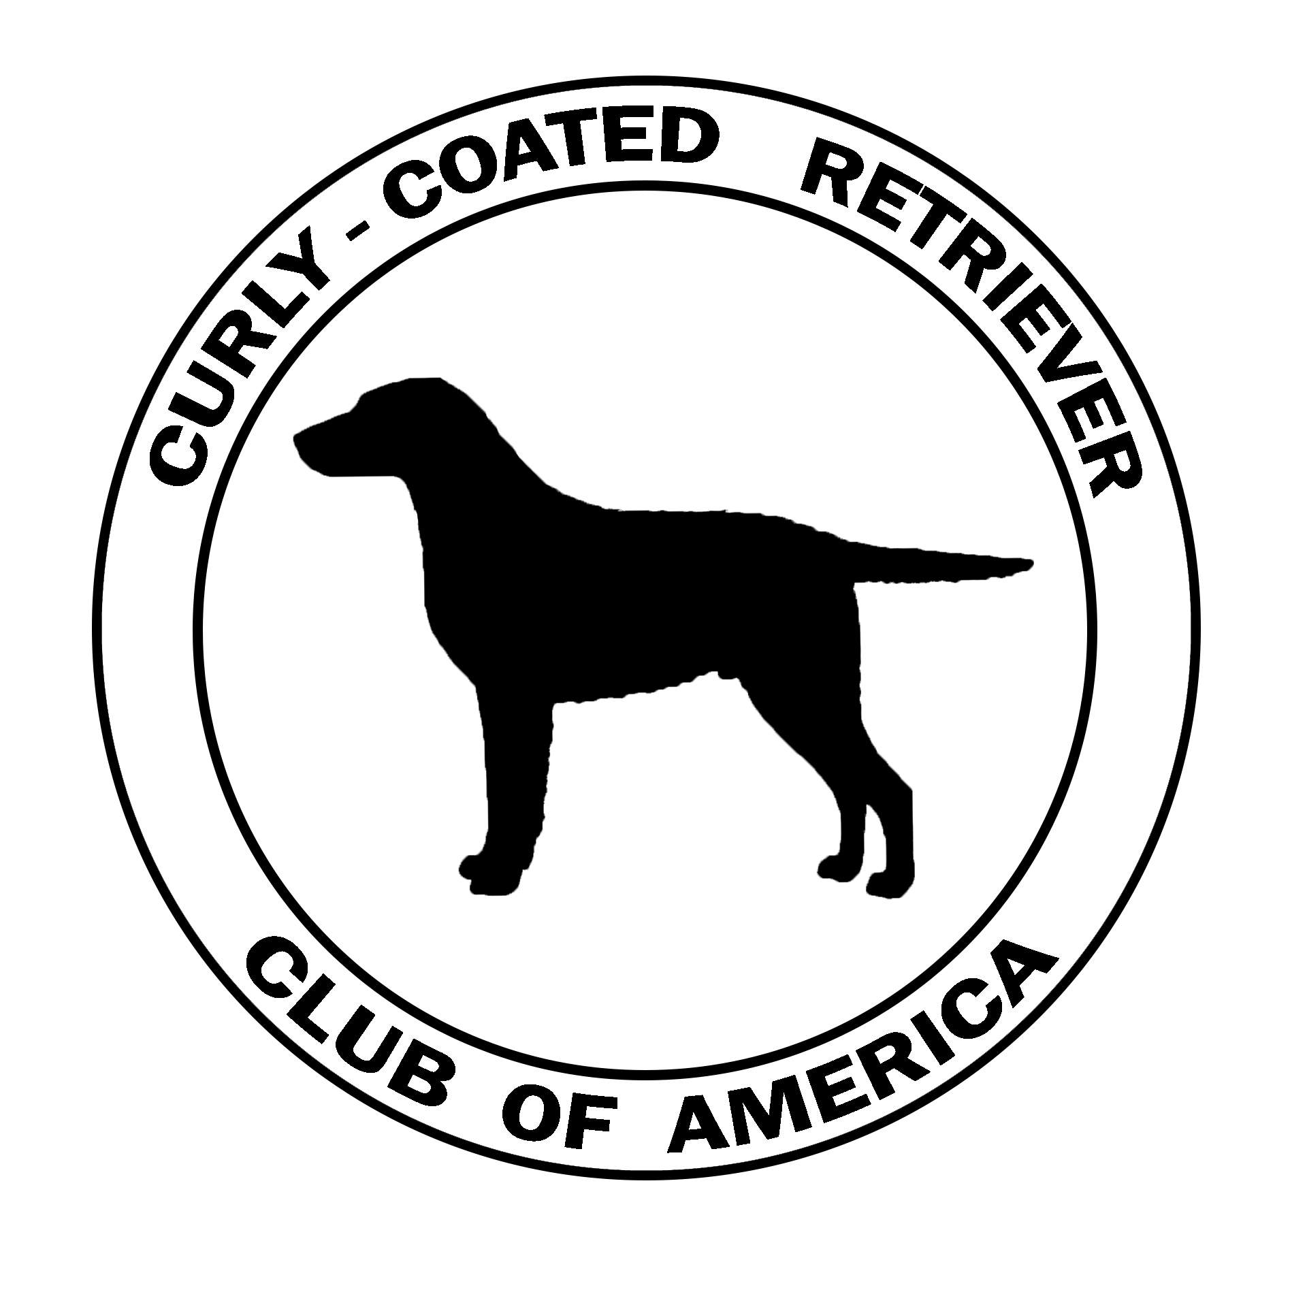  APPLICATION for  REGISTER OF MERIT |  | Submit to:  Mary Kay Morel, Records Chair  8083 Saddleback Place  Maineville, Ohio 43539-9507  email: morel2@aol.com
Application Type:  □ ROM (Register of Merit) □ ROMX (Register of Merit Excellent) | Gender □ Male □ Female
Dog’s Registered Name (include titles): | Breeder(s):
Dog’s Call Name: | Owner(s):
Sire’s Registered Name: | Owner(s) email and Phone No.:
Dam’s Registered Name: | Ship-to Address:

Total ROM Requirements Total ROMX Requirements
Sires | 100 points | 5 championships | 1 obedience | 1 field |  | 200 points | 10 championships | 4 obedience | 4 field
Dams | 75 points | 3 championships | 1 obedience | 1 field |  | 150 points | 6 championships | 2 obedience | 2 field
In the following sections, check titles that apply and specify the registered names of the Produce satisfying that requirement.

Conformation Points
 | AKC Ch – 10 Points Each
 | Produce Names
1 |  | 6
2 |  | 7
3 |  | 8
4 |  | 9
5 |  | 10

Field Points
 | WC | WCX | WCQ | JH | SH | MH | FC | AFC | SR | WR | MHR
Points Each | 10 | 10 | 15 | 10 | 10 | 15 | 15 | 15 | 10 | 10 | 15
Produce Name(s)

Obedience & Agility Points
 | CD | CDX | UD | UDX | OTCh | NA | OA | AX | MX
Points Each | 5 | 5 | 10 | 10 | 15 | 5 | 5 | 10 | 10
Produce Name(s)

Tracking Points Certification Points
 | TD | TDX |  | *** send copies of any TT or CGC certificates earned along with this application. | CGC | TT
Points Each | 5 | 10 |  | Points Each | 5 | 5
Produce Name(s) |  |  |  | Produce Name(s)

I certify that all statements contained herein are accurate and true. I understand that accomplishments will be verified prior to the title being awarded.
Owner’s Signature(s) | Date
At least one owner must be a member of the CCRCA and in good standing with both the CCRCA and the AKC.

